Silikometer Ultra: users
August 2001

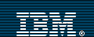
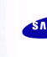
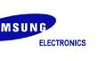
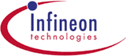

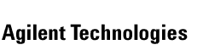
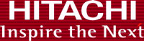

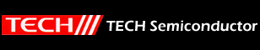

Advance Semiconductor, China
Agilent, UK
Degussa-Hüls, Germany
Goema, Germany
Hitachi Semiconductor, Germany
Hoechst, Germany
Hüls-Infracor, Germany
IBM Deutschland
Infineon Austria
Infineon Germany

Infraserv Germany
JSR Electronics, Netherlands
Philips Semiconductors, Netherlands
Samsung General Chemical, Korea
Siemens Germany
ST Microelectronics, Italy
Systems on Silicon, Singapore
TECH Semiconductor, Singapore
TSMC, Taiwan
UMC, Taiwan
WIN Semiconductor, Taiwan

